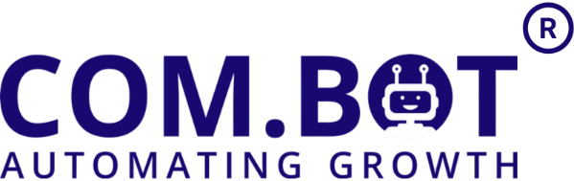
Meta Business Partner
501,Trinity Orion, Vesu Main Road, Surat, Gujarat, India - 395007 | GSTIN - 24DUKPS5774J1ZV
Email :- Sales@Com.Bot | Ph :- +91 83201 86467
🚀 Plan: LifeTime Whitelabel (Christmas offer) valid till 31st December.

White Label License: ₹30,000 + Gst(One-time cost)
- No user limit
- Complete white-label platform setup
- Custom domain configuration
- Branding customization
- Advanced crm and channel section online group training
- 1k Channel wallet credits

Per User (Starter Plan) ₹100 (per user/month)
- Unlimited WhatsApp Channels
- 1 Million Contacts
- Do It Yourself Bot Builder
- Support - WABA And CRM ~ SLA 3 Days
- 10 Messages / Second Speed Limit

✅ Inclusion For Each Customer Account
CRM
- CRM access included
- Unlimited WhatsApp Channels
- 1 Million Contacts
- 5 GB Data Storage

Ecommerce
- 1 WhatsApp Store
- 100 Products
- 100 Orders / month
- 100 Abandoned Cart Records

Bots
- Do-It-Yourself Bot Builder
- External Actions / Apps Not Included

Support
- WABA & CRM SLA: 3 Days
- 10 Messages/Second Speed Limit

Per User (Wa Bulk API-Only Plan) FREE till Dec 2026 (per user/month)
- 5 WhatsApp Channels
- CRM & LIve Chat
- 1 Million Contacts
- No Bot Builders & Automation
- Support - WABA And CRM ~ SLA 3 Days
- 10 Messages / Second Speed Limit

Add-Ons (Optional)
Add-On | Price | Details
External Actions | ₹200/month | 5000 executions per month
Team Member | ₹50/month | Per additional team member
Instagram / Messenger / RCS | ₹200/month | Per additional social channel
Calendars Bot | ₹200/month | Calendar management and scheduling
QR Ticket | ₹1/ticket | Per dynamic QR ticket generated
Dynamic Image | ₹0.5/image | Per image generated dynamically

🛠️ Support & Training Services

Service | Rate | Description
Onboarding Support | ₹1250/hour | Sub-account based onboarding setup
Basic Training | ₹1250/hour | CRM, Inbox, and WhatsApp Business training (
Ecommerce Setup | ₹2000/hour | Product, orders, cart integration and setup
Bot Training | ₹2000/hour | Building basic bots, logic, flow design
Automation Training | ₹2000/hour | Training for CRM workflows and automations

📌 Important Notes
- All prices are subject to annual revision.
- Conversation charges will be billed as per Meta’s official rates.
- Taxes extra as applicable as per Indian Law.
- Additional Add-ons & upgrades will be made available as our platform evolves.

